Psychological Factors of Patients Who Have Vitiligo

Vitiligo is a skin disease that is caused by the destruction of melanocytes in skin cells which results in depigmentation to occur on the skin. There is currently no cure for this disease and scientists have been researching a solution to deter the cause of depigmentation. While finding the cure for vitiligo is urgent, a problem inherently for vitiligo patients is their well-being and their emotional stability.
My name is Rindha Kola. Over the past three years, I have been a part of the AP Seminar and AP Research class at Marquette High School, taught by Dr. Cathy Farrar, completing Authentic Science Research I, II, and III. In this class, we conduct our own independent research and share it at a yearly science symposium while also competing in out of town science competitions. I eagerly joined this class so I could pursue and find more information about Vitiligo as I have been living with it since I was 5.
Sophomore and junior year, I looked at the psychological factors of Vitiligo patients using Maslow’s Hierarchy of Needs and Ryff’s Psychological Well-Being scale, and I compared those factors with people who have depression to further the study. A survey was made based on the 6 dimensions of Ryff’s Well Being Scale and 5 categories of Maslow’s Hierarchy of Needs. This survey was distributed to patients who are clinically diagnosed with vitiligo, depression, and neither. After converting the survey’s responses into numerical data, and using the IBM SPSS Statistics Software to conduct an independent sample t-test, many statistically significant factors were revealed. Patients who have depression and vitiligo, both score lower on the “positive relations with others” of PWS and “love/belonging” of Maslow’s. Overall, patients with vitiligo and depression have a lower well-being than total summation of the study. Below, is a poster that summarizes my whole study for those two years.
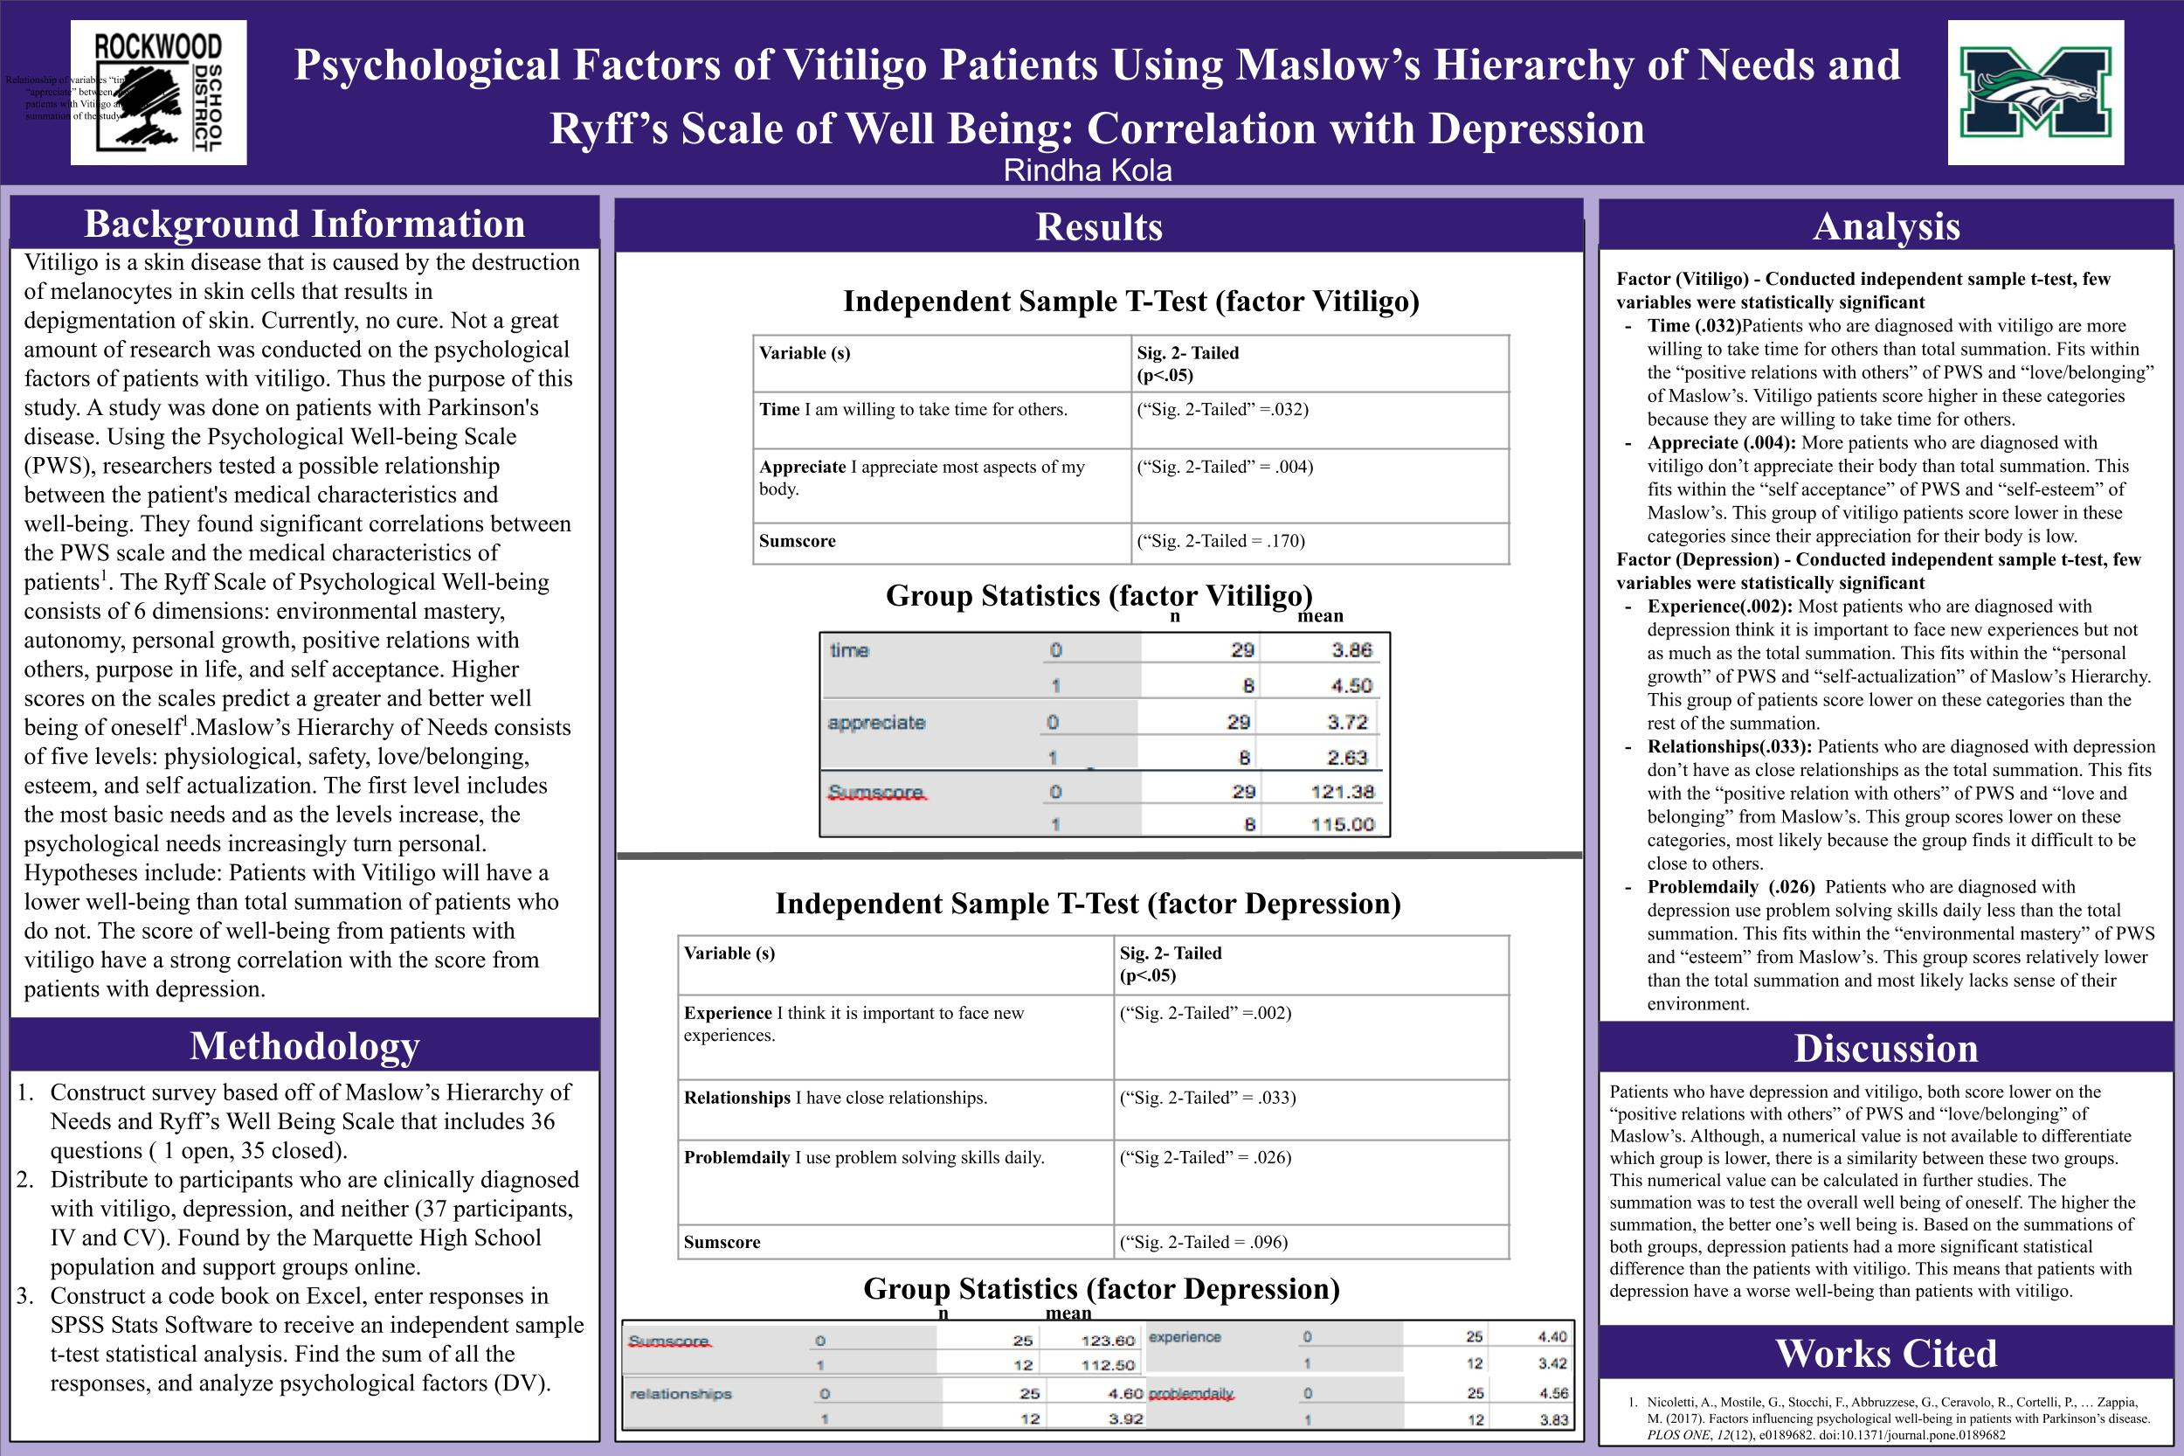
The research from those two years focused on a concrete and quantitative method in analyzing the psychological factors between people who had vitiligo, depression, or neither. To answer questions about the participants at a deeper level, and to find similarities between their experiences in each category of Maslow’s Hierarchy and Ryff’s Psychological Well-Being, an embedded, multiple-case study was conducted. The two cases were patients who have Vitiligo and the patients who don’t. A deep analysis of the psychological factors of people who have vitiligo isn’t present often in the research world. Thus, this case study investigated situations where little is known about this topic. It also explored complexities that are beyond the scope of more controlled approaches, as what was done in the past two years.
An interview was made based on the 6 dimensions of Ryff’s Well Being Scale and 5 categories of Maslow’s Hierarchy of Needs. Four patients who had Vitiligo and four who did not have Vitiligo were interviewed and audio-recorded. The interviews lasted around 20 to 30 minutes. Using a thematic analysis and after matching the responses to the six themes from Maslow’s and Ryff’s, many major trends were revealed. In Autonomy/Self-Actualization and Esteem Needs/Self-Acceptance the Vitiligo group scored lower than the Non-Vitiligo group. This means that they are lower on the well-being scale. Another major trend is that participants who have Vitiligo have an external locus of control when talking about what makes them happier than people who don’t have Vitiligo.
More about my embedded, multiple case study will be posted. Or contact me!
I am continuing my education at Saint Louis University as part of the Medical Scholars Program, majoring in psychology and minoring in biology. I hope to further my studies on this under researched topic. Now knowing the psychological factors that come with having Vitiligo, it is even more apparent to be allies with one another, embracing our beautiful spots and breaking the social stigmatization that comes with this condition.

